**TASK DESCRIPTION**

**Overview**

* Subjects carry out a binary choice monetary lottery task while we monitor fixations
* In half of the trials they choose between win lotteries, each associated with a probability *p* of earning $10 and a probability *1-p* of $0
* In the other half of the trials the choose between loss trials: each associated with a probability *p* of loosing $10 and a probability *1-p* of $0.

**Outline of task events**

1. Administer informed consent
2. Written task instructions
3. 16 practice trials (no eye-tracking, they don’t count for payment): 8 in win frame and 8 in loss frame. Each block of 8 trials starts with screen “Win/Loss trials” for 2 seconds
4. Eye-tracking calibration
5. Block of 200 trials
6. Eye-trackign re-calibration
7. Block of 200 trials
8. Random selection of trials that count for payoff and payment.

**Task description**

* Each trial is structured as follows:  
  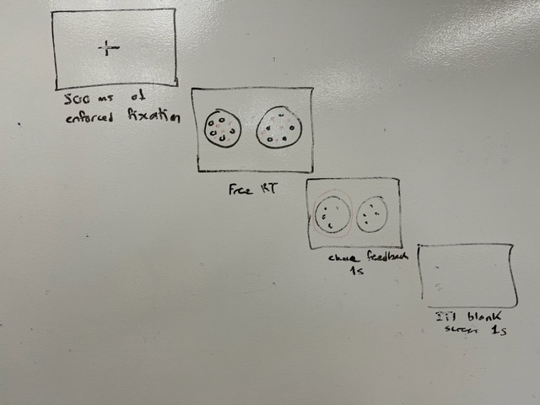
* Subjects perform 400 trials of the task, divided into two 200 trial blocks: one for wins and one for losses, with order counterbalanced across subjects
* Each trial the probability of each win or loss shown on the screen is selected independently from p = 45%, 46%, ...., 55%
* The stimuli are then assembled as shown here.  
  Note that each option has 100 small balls, p of them are colored in red for loss trials and green for win trials, and 1-p of them are colored white  
  The location of the balls within the circle is randomized for each stimulus, but the overall location of balls within the circle can be fixed across stimuli and trials  
  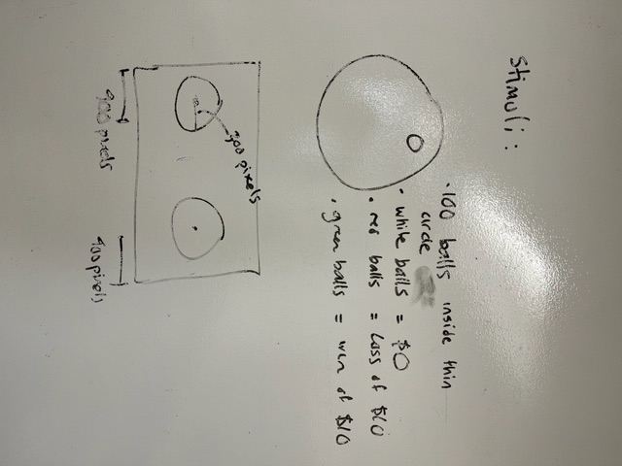
* At the end of the experiment the subjects pick a number labelled 1-200 from an urn and the lottery chosen in that trial in both the win and lost trials is played.  
  This is done by preparing an urn with the right number of balls and randomly choosing one for each case.
* Fixation data is collected during the experiment
* Subjects are paid a $40 show-up fee + whatever they earn/loose from the randomly chosen lottery trails

**Note**

* Software should save data for each block of trials
* You should have a piece of code to be used at the end: randomly selected trial number is entered, and this looks into data for choice made in that trial in both win and loss cases.

**About eye-tracking**

* The eye-tracking we are using is the Eyelink 1000, and it is Version 4.594
* We are collecting with these settings: Desktop (Remote); Monocular (Left Eye); 16mm lens; Target Sticker.
* The sampling rate is 500 Hz.
* Pupil area is collected, measured in pixels. (There is also an option to collect pupil diameter instead, but currently it is set to area).

**DATABASE DESCRIPTIONS**

**DATABASE DESCRIPTIONS**

NOTE:

* Every task results in four datasets
* Every piece of software should take as input the unique subject ID
* Each database should be a .csv file

*CHOICE DATABASES*

* Separate database stored for each choice block
* File name should be “choice_subject_ID_win” or ““choice_subject_ID_loss” depending on the block type
* Each row is one choice trial
* Each column is one of the following variable names:
  + subject_ID
  + trial_number (1 to 200)
  + Tryal type: win or loss
  + P_left
  + p_right
  + choice (“left”, “right”)
  + rt (in milli-seconds)

*RAW FIXATIONS DATABASES*

* Separate database stored for each choice block
* File name should be “raw_fixations_subject_ID_win” or ““raw_fixations_subject_ID_loss” depending on the block type
* Each row is one eye-tracking measurement within a trial (thus, if the eye-tracking measures fixations at 1000 Hz, and a trial RT = 2 s, there are 2000 rows associated with that trial
* Each column is one of the following variable names:
  + subject_ID
  + trial_number (1 to 200)
  + trial_time (this is the time within the trial at which the measurement is taken, with time at which items appear equal to zero)
  + ROI (region of interest being fixated, “left”, “right”, or NA when not available)
  + x_position (x coordinate of eye-fixation, in pixels, left = 0, NA when note available)
  + y_position (x coordinate of eye-fixation, in pixels, top = 0, NA when note available)
  + pupil _dilation (in pixels)

About pupil dilation measures:

Pupil Size Data Pupil size is also measured by the EyeLink 1000 system, at up to 2000 samples per second depending on your tracker version. It may be reported as pupil area, or pupil diameter. The pupil size data is not calibrated, and the units of pupil measurement will vary with subject setup. Pupil size is an integer number, in arbitrary units. Typical pupil area is 100 to 10000 units, with a precision of 1 unit, while pupil diameter is in the range of 400-16000 units. Both measurements are noise-limited, with noise levels of 0.2% of the diameter. This corresponds to a resolution of 0.01 mm for a 5 mm pupil. Pupil size measurements are affected by up to 10% by pupil position, due to the optical distortion of the cornea of the eye, and camera-related factors. If research using pupil size is to be performed, the subject should not move their eyes during the trials. They can be presented with a fixation point with aural stimulus presentation, or a single stimulus position at display center may be used. It is also possible to counterbalance stimulus position during the experiment.